**Program No:1 Date: 21.09.2023**

**Aim:**

Design a login form with username and password using linear layout and toast valid credentials

**Program Code:**

**activity_main.xml:**

<?xml version="1.0" encoding="utf-8"?>

<LinearLayout xmlns:android="http://schemas.android.com/apk/res/android"

xmlns:app="http://schemas.android.com/apk/res-auto"

xmlns:tools="http://schemas.android.com/tools"

android:layout_width="match_parent"

android:layout_height="match_parent"

android:orientation="vertical"

tools:context=".MainActivity">

<TextView

android:layout_width="wrap_content"

android:layout_height="wrap_content"

android:text="LOGIN" />

<EditText

android:layout_width="wrap_content"

android:layout_height="wrap_content"

android:hint="username"

android:id="@+id/et1" />

<EditText

android:layout_width="wrap_content"

android:layout_height="wrap_content"

android:hint="Password"

android:id="@+id/et2" />

<Button

android:layout_width="wrap_content"

android:layout_height="wrap_content"

android:text="LOGIN"

android:id="@+id/b"/>

</LinearLayout>

**MainActivity.java:**

package com.example.login;

import androidx.appcompat.app.AppCompatActivity;

import android.os.Bundle;

import android.view.View;

import android.widget.Button;

import android.widget.EditText;

import android.widget.Toast;

public class MainActivity extends AppCompatActivity {

@Override

protected void onCreate(Bundle savedInstanceState) {

super.onCreate(savedInstanceState);

setContentView(R.layout.activity_main);

EditText et1=findViewById(R.id.et1);

EditText et2=findViewById(R.id.et2);

Button b=findViewById(R.id.b);

b.setOnClickListener(new View.OnClickListener() {

@Override

public void onClick(View view) {

String a=et1.getText().toString();

String b=et2.getText().toString();

if (a.equals("User")&& b.equals("123")) Toast.makeText(getApplicationContext(),"Login Successfully",Toast.LENGTH_SHORT).show();

else

Toast.makeText(getApplicationContext(),"Login Failed",Toast.LENGTH_SHORT).show();

}

});

}

}

**Result**

Program compiled successfully and output verified.

**Output**

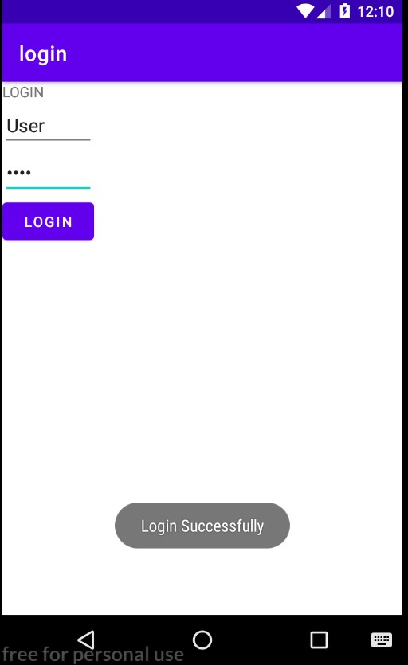

**Program No:2**  **Date: 05.10.2023**

**Aim:**

Write a program to demonstrate activity lifecycle.

**Program Code:**

**MainActivity.java:**

package com.example.lifecycle;

import androidx.appcompat.app.AppCompatActivity;

import android.os.Bundle;

import android.util.Log;

public class MainActivity extends AppCompatActivity {

@Override

protected void onCreate(Bundle savedInstanceState) {

super.onCreate(savedInstanceState);

setContentView(R.layout.activity_main);

}

@Override

protected void onStart() {

super.onStart();

Log.d("lifecycle", "onStart invoked");

}

@Override

protected void onResume() {

super.onResume();

Log.d( "lifecycle", "onResume invoked");

}

@Override

protected void onPause() {

super.onPause();

Log.d("lifecycle", "onPause invoked");

}

@Override

protected void onStop() {

super.onStop();

Log.d("lifecycle", "onStop invoked");

}

@Override

protected void onRestart() {

super.onRestart();

Log.d("lifecycle", "onRestart invoked");

}

@Override

protected void onDestroy(){

super.onDestroy();

Log.d("lifecycle", "onDestroy invoked");

}

}

**Result**

Program completed successfully and output verified.

**Output**



**Program No:3 Date: 06.10.2023**

**Aim:**

Implementing basic arithmetic operation of a simple calculator.

**Program Code:**

**activity_main.xml:**

<?xml version="1.0" encoding="utf-8"?>

<LinearLayout xmlns:android="http://schemas.android.com/apk/res/android"

xmlns:app="http://schemas.android.com/apk/res-auto"

xmlns:tools="http://schemas.android.com/tools"

android:layout_width="match_parent"

android:layout_height="match_parent"

android:orientation="vertical"

tools:context=".MainActivity">

<EditText

android:layout_width="wrap_content"

android:layout_height="wrap_content"

android:id="@+id/et1"

android:hint="Enter first no:"/>

<EditText

android:layout_width="wrap_content"

android:layout_height="wrap_content"

android:id="@+id/et2"

android:hint="Enter second no:"/>

<TextView

android:layout_width="wrap_content"

android:layout_height="wrap_content"

android:id="@+id/tv1"

android:hint="Result"/>

<Button

android:layout_width="wrap_content"

android:layout_height="wrap_content"

android:text="clear"

android:id="@+id/c"/>

<LinearLayout

android:layout_width="wrap_content"

android:layout_height="wrap_content"

android:orientation="horizontal">

<Button

android:layout_width="wrap_content"

android:layout_height="wrap_content"

android:text="ADD"

android:id="@+id/b1"/>

<Button

android:layout_width="wrap_content"

android:layout_height="wrap_content"

android:text="SUB"

android:id="@+id/b2"/>

<Button

android:layout_width="wrap_content"

android:layout_height="wrap_content"

android:text="MUL"

android:id="@+id/b3"/>

<Button

android:layout_width="wrap_content"

android:layout_height="wrap_content"

android:text="DIV"

android:id="@+id/b4"/>

</LinearLayout>

</LinearLayout>

**MainActivity.java:**

package com.example.calculator;

import androidx.appcompat.app.AppCompatActivity;

import android.os.Bundle;

import android.view.View;

import android.widget.Button;

import android.widget.EditText;

import android.widget.TextView;

public class MainActivity extends AppCompatActivity {

@Override

protected void onCreate(Bundle savedInstanceState) {

super.onCreate(savedInstanceState);

setContentView(R.layout.activity_main);

EditText et1, et2;

Button b1, b2, b3, b4, c;

TextView tv1;

et1 = findViewById(R.id.et1);

et2 = findViewById(R.id.et2);

tv1 = findViewById(R.id.tv1);

b1 = findViewById(R.id.b1);

b2 = findViewById(R.id.b2);

b3 = findViewById(R.id.b3);

b4 = findViewById(R.id.b4);

c = findViewById(R.id.c);

b1.setOnClickListener(new View.OnClickListener() {

@Override

public void onClick(View view) {

Double a = Double.parseDouble(et1.getText().toString());

Double b = Double.parseDouble(et2.getText().toString());

Double r = a + b;

tv1.setText("Result=" + String.valueOf(r));

}

});

b2.setOnClickListener(new View.OnClickListener() {

@Override

public void onClick(View view) {

Double a = Double.parseDouble(et1.getText().toString());

Double b = Double.parseDouble(et2.getText().toString());

Double r = a - b;

tv1.setText("Result=" + String.valueOf(r));

}

});

b3.setOnClickListener(new View.OnClickListener() {

@Override

public void onClick(View view) {

Double a = Double.parseDouble(et1.getText().toString());

Double b = Double.parseDouble(et2.getText().toString());

Double r = a * b;

tv1.setText("Result=" + String.valueOf(r));

}

});

b4.setOnClickListener(new View.OnClickListener() {

@Override

public void onClick(View view) {

Double a = Double.parseDouble(et1.getText().toString());

Double b = Double.parseDouble(et2.getText().toString());

Double r = a / b;

tv1.setText("Result=" + String.valueOf(r));

}

});

c.setOnClickListener(new View.OnClickListener() {

@Override

public void onClick(View view) {

et1.setText("");

et2.setText("");

tv1.setText("");

}

});

}

}

**Result**

Program compiled successfully and output verified.

**Output**

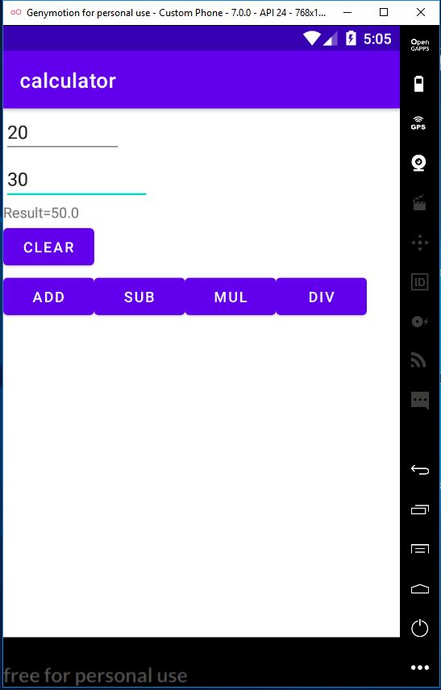  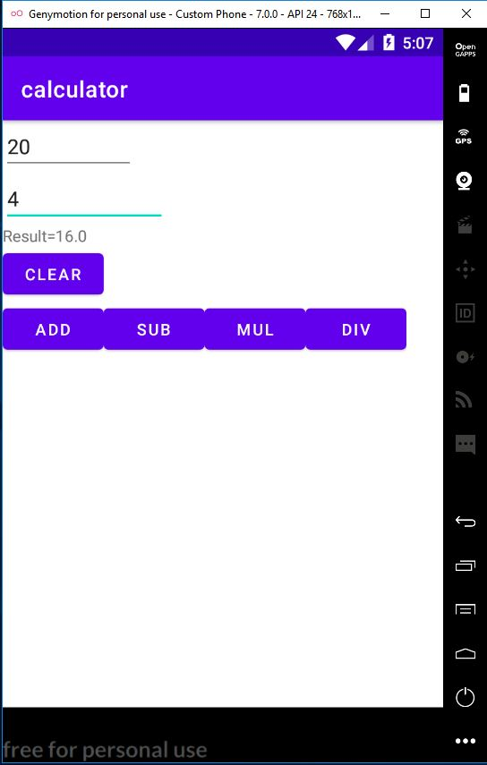 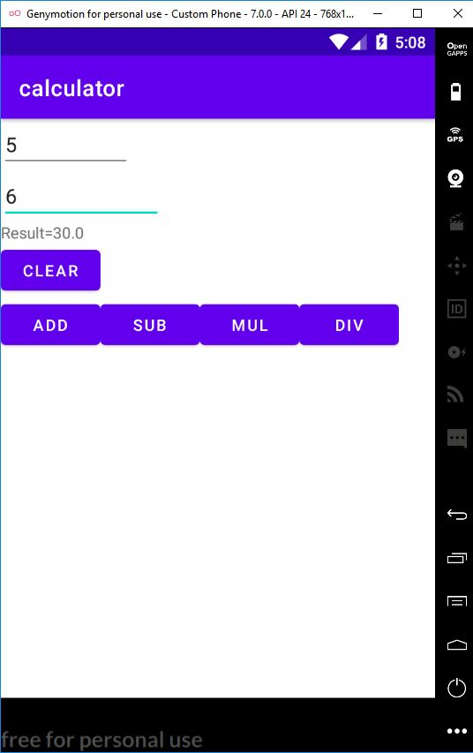

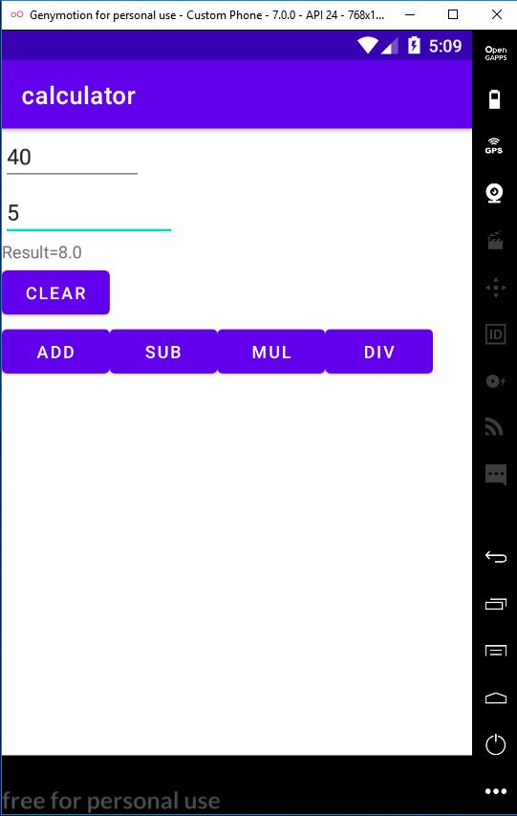 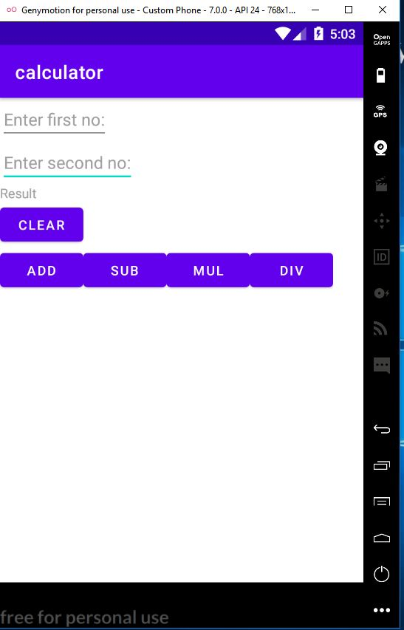

**Program No:4 Date: 12.10.23**

**Aim:** Implement validation on various UI controls.

**Program Code:**

**activity_main.xml:**

<?xml version="1.0" encoding="utf-8"?>

<LinearLayout xmlns:android="http://schemas.android.com/apk/res/android"

xmlns:tools="http://schemas.android.com/tools"

android:layout_width="match_parent"

android:layout_height="match_parent"

tools:context=".MainActivity"

android:orientation="vertical">

<TextView

android:layout_width="wrap_content"

android:layout_height="wrap_content"

android:text="REGISTRATION"

android:textColor="@color/design_default_color_error"

android:textSize="30dp"/>

<EditText

android:layout_width="match_parent"

android:layout_height="wrap_content"

android:hint="NAME"

android:id="@+id/name"/>

<EditText

android:layout_width="match_parent"

android:layout_height="wrap_content"

android:hint="MOBILE NUMBER"

android:id="@+id/mobno"/>

<EditText

android:layout_width="match_parent"

android:layout_height="wrap_content"

android:hint="AGE"

android:id="@+id/age"/>

<TextView

android:layout_width="wrap_content"

android:layout_height="wrap_content"

android:text="GENDER"

android:textSize="20dp"

android:textColor="@color/design_default_color_primary"/>

<RadioGroup

android:layout_width="wrap_content"

android:layout_height="wrap_content"

android:id="@+id/rgroup">

<RadioButton

android:layout_width="wrap_content"

android:layout_height="wrap_content"

android:id="@+id/rb1"

android:text="Male"/>

<RadioButton

android:layout_width="wrap_content"

android:layout_height="wrap_content"

android:id="@+id/rb2"

android:text="Female"/>

</RadioGroup>

<CheckBox

android:layout_width="wrap_content"

android:layout_height="wrap_content"

android:text="i agree all terms and conditions"

android:id="@+id/cb"/>

<Button

android:layout_width="wrap_content"

android:layout_height="wrap_content"

android:text="Submit"

android:id="@+id/b"/>

</LinearLayout>

**MainActivity.java:**

package com.example.registration;

import androidx.appcompat.app.AppCompatActivity;

import android.os.Bundle;

import android.view.View;

import android.widget.Button;

import android.widget.CheckBox;

import android.widget.EditText;

import android.widget.RadioButton;

import android.widget.RadioGroup;

import android.widget.Toast;

public class MainActivity extends AppCompatActivity {

EditText name;

EditText mobno;

EditText age;

RadioGroup rgroup;

RadioButton male;

RadioButton female;

CheckBox chbox;

Button button;

@Override

protected void onCreate(Bundle savedInstanceState) {

super.onCreate(savedInstanceState);

setContentView(R.layout.activity_main);

name = findViewById(R.id.name);

mobno = findViewById(R.id.mobno);

age = findViewById(R.id.age);

rgroup = findViewById(R.id.rgroup);

male = findViewById(R.id.rb1);

female = findViewById(R.id.rb2);

chbox = findViewById(R.id.cb);

button = findViewById(R.id.b);

button.setOnClickListener(new View.OnClickListener() {

@Override

public void onClick(View view) {

if (error()) {

Toast.makeText(getApplicationContext(), "Registration successful", Toast.LENGTH_LONG).show();

}

}

});

}

private boolean error() {

if (name.getText().toString().length() == 0) {

Toast.makeText(getApplicationContext(), "Please enter the name", Toast.LENGTH_LONG).show();

return false;

} else if (mobno.getText().toString().length() == 0) {

Toast.makeText(getApplicationContext(), "please enter mobile number", Toast.LENGTH_LONG).show();

return false;

} else if (mobno.getText().toString().length() != 10) {

Toast.makeText(getApplicationContext(), "please enter 10 numbers", Toast.LENGTH_LONG).show();

return false;

} else if (age.getText().toString().length() == 0) {

Toast.makeText(getApplicationContext(), "please enter age", Toast.LENGTH_LONG).show();

return false;

} else if (!male.isChecked() && !female.isChecked()) {

Toast.makeText(getApplicationContext(), "please choose radio button", Toast.LENGTH_LONG).show();

return false;

} else if (!chbox.isChecked()) {

Toast.makeText(getApplicationContext(), "Please click on checkbox", Toast.LENGTH_LONG).show();

return false;

} else {

return true;

}

}

}

**Result**

Program compiled successfully and output verified.

**Output**

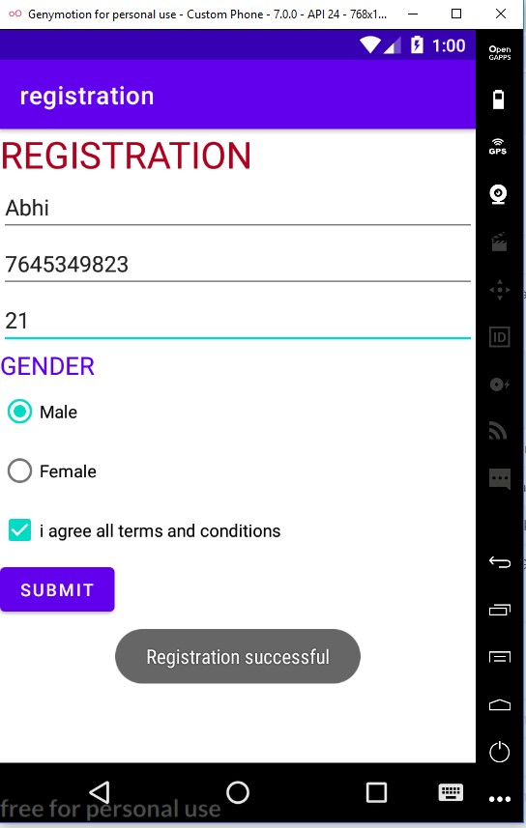

**Program No:5 Date: 20.10.23**

**Aim:**

Program to design a registration activity and store registration details in local memory of phone

using intent and shared preferences.

**Program Code:**

**activity_main.xml:**

<?xml version="1.0" encoding="utf-8"?>

<LinearLayout xmlns:android="http://schemas.android.com/apk/res/android"

xmlns:app="http://schemas.android.com/apk/res-auto"

xmlns:tools="http://schemas.android.com/tools"

android:layout_width="match_parent"

android:layout_height="match_parent"

tools:context=".MainActivity"

android:orientation="vertical">

<TextView

android:layout_width="wrap_content"

android:layout_height="wrap_content"

android:text="Registration"

android:textColor="@color/black"

android:textSize="25dp"

app:layout_constraintBottom_toBottomOf="parent"

app:layout_constraintLeft_toLeftOf="parent"

app:layout_constraintRight_toRightOf="parent"

app:layout_constraintTop_toTopOf="parent"

android:layout_gravity="center" />

<EditText

android:layout_width="wrap_content"

android:layout_height="wrap_content"

android:hint="Enter your Name"

android:id="@+id/name"/>

<EditText

android:layout_width="wrap_content"

android:layout_height="wrap_content"

android:hint="Enter your Age"

android:id="@+id/age"/>

<EditText

android:layout_width="wrap_content"

android:layout_height="wrap_content"

android:hint="Enter your Email"

android:inputType="textEmailAddress"

android:id="@+id/email"/>

<EditText

android:layout_width="wrap_content"

android:layout_height="wrap_content"

android:hint="Enter your Address"

android:id="@+id/address"/>

<EditText

android:layout_width="wrap_content"

android:layout_height="wrap_content"

android:hint="Enter your qualification"

android:id="@+id/quali"/>

<Button

android:layout_width="wrap_content"

android:layout_height="wrap_content"

android:text="Submit"

android:id="@+id/b"/>

</LinearLayout>

**MainActivity.java**

package com.example.register;

import androidx.appcompat.app.AppCompatActivity;

import android.content.Intent;

import android.content.SharedPreferences;

import android.os.Bundle;

import android.view.View;

import android.widget.Button;

import android.widget.EditText;

public class MainActivity extends AppCompatActivity {

EditText name,age,email,quali,address;

Button button;

@Override

protected void onCreate(Bundle savedInstanceState) {

super.onCreate(savedInstanceState);

setContentView(R.layout.activity_main);

name=findViewById(R.id.name);

age=findViewById(R.id.age);

email=findViewById(R.id.email);

address=findViewById(R.id.address);

quali=findViewById(R.id.quali);

button=findViewById(R.id.b);

button.setOnClickListener(new View.OnClickListener() {

@Override

public void onClick(View view) {

Intent i=new Intent(MainActivity.this,MainActivity2.class);

startActivity(i);

}

});

}

@Override

protected void onResume(){

super.onResume();

SharedPreferences sh= getSharedPreferences("sharedpref",MODE_PRIVATE);

String s1=sh.getString("name","");

int a=sh.getInt("age",0);

String s2=sh.getString("email","");

String s3=sh.getString("address","");

String s4=sh.getString("qualification","");

name.setText(s1);

age.setText(String.valueOf(a));

email.setText(s2);

address.setText(s3);

quali.setText(s4);

}

@Override

protected void onPause(){

super.onPause();

SharedPreferences sh=getSharedPreferences("sharedpref",MODE_PRIVATE);

SharedPreferences.Editor myedit=sh.edit();

myedit.putString("name",name.getText().toString());

myedit.putInt("age",Integer.parseInt(age.getText().toString()));

myedit.putString("email",email.getText().toString());

myedit.putString("address",address.getText().toString());

myedit.putString("qualification",quali.getText().toString());

myedit.commit();

}

}

**Result**

Program compiled successfully and output verified.

**Output**

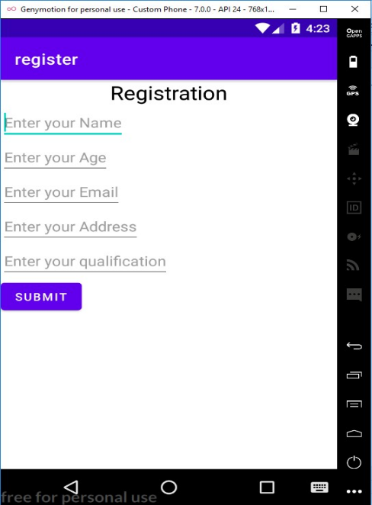

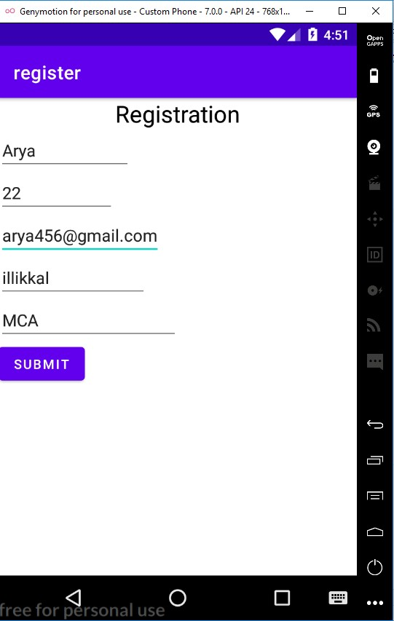

**Program No:6 Date: 20.10.23**

**Aim:**

Design a simple calculator using GridLayout.

**Program Code:**

**activity_main.xml:**

<?xml version="1.0" encoding="utf-8"?>

<GridLayout xmlns:android="http://schemas.android.com/apk/res/android"

xmlns:app="http://schemas.android.com/apk/res-auto"

xmlns:tools="http://schemas.android.com/tools"

android:layout_width="match_parent"

android:layout_height="match_parent"

tools:context=".MainActivity"

android:orientation="vertical">

<TextView

android:layout_height="wrap_content"

android:layout_width="wrap_content"

android:text="First Number"

android:textColor="@color/black"

android:layout_row="0"

android:layout_column="0"/>

<EditText

android:layout_width="wrap_content"

android:layout_height="wrap_content"

android:id="@+id/et1"

android:layout_row="0"

android:layout_column="1" />

<TextView

android:layout_height="wrap_content"

android:layout_width="wrap_content"

android:text="Second Number"

android:textColor="@color/black"

android:layout_row="1"

android:layout_column="0"/>

<EditText

android:layout_width="wrap_content"

android:layout_height="wrap_content"

android:id="@+id/et2"

android:layout_row="1"

android:layout_column="1"/>

<TextView

android:layout_width="wrap_content"

android:layout_height="wrap_content"

android:id="@+id/txt1"

android:layout_column="0"

android:layout_row="2"/>

<Button

android:layout_width="wrap_content"

android:layout_height="wrap_content"

android:text="Clear"

android:id="@+id/b5"

android:layout_row="3"

android:layout_column="0"/>

<Button

android:layout_width="wrap_content"

android:layout_height="wrap_content"

android:id="@+id/b1"

android:text="ADD"

android:layout_column="0"

android:layout_row="4"/>

<Button

android:layout_width="wrap_content"

android:layout_height="wrap_content"

android:id="@+id/b2"

android:text="SUB"

android:layout_column="1"

android:layout_row="4"/>

<Button

android:layout_width="wrap_content"

android:layout_height="wrap_content"

android:id="@+id/b3"

android:text="MUL"

android:layout_row="4"

android:layout_column="2"/>

<Button

android:layout_width="wrap_content"

android:layout_height="wrap_content"

android:id="@+id/b4"

android:text="DIV"

android:layout_row="4"

android:layout_column="3"/>

</GridLayout>

**MainActivity.java**

package com.example.gridcalculator;

import androidx.appcompat.app.AppCompatActivity;

import android.os.Bundle;

import android.view.View;

import android.widget.Button;

import android.widget.EditText;

import android.widget.TextView;

public class MainActivity extends AppCompatActivity {

@Override

protected void onCreate(Bundle savedInstanceState) {

super.onCreate(savedInstanceState);

setContentView(R.layout.activity_main);

Button b1=findViewById(R.id.b1);

Button b2=findViewById(R.id.b2);

Button b3=findViewById(R.id.b3);

Button b4=findViewById(R.id.b4);

Button b5=findViewById(R.id.b5);

EditText et1=findViewById(R.id.et1);

EditText et2=findViewById(R.id.et2);

TextView txt1=findViewById(R.id.txt1);

b1.setOnClickListener(new View.OnClickListener() {

@Override

public void onClick(View view) {

Double a1=Double.parseDouble(et1.getText().toString());

Double a2=Double.parseDouble(et2.getText().toString());

Double r=a1+a2;

txt1.setText("Result="+String.valueOf(r));

}

});

b2.setOnClickListener(new View.OnClickListener() {

@Override

public void onClick(View view) {

Double a1=Double.parseDouble(et1.getText().toString());

Double a2=Double.parseDouble(et2.getText().toString());

Double r=a1-a2;

txt1.setText("Result="+String.valueOf(r));

}

});

b3.setOnClickListener(new View.OnClickListener() {

@Override

public void onClick(View view) {

Double a1=Double.parseDouble(et1.getText().toString());

Double a2=Double.parseDouble(et2.getText().toString());

Double r=a1*a2;

txt1.setText("Result="+String.valueOf(r));

}

});

b4.setOnClickListener(new View.OnClickListener() {

@Override

public void onClick(View view) {

Double a1=Double.parseDouble(et1.getText().toString());

Double a2=Double.parseDouble(et2.getText().toString());

Double r=a1/a2;

txt1.setText("Result="+String.valueOf(r));

}

});

b5.setOnClickListener(new View.OnClickListener() {

@Override

public void onClick(View view) {

et1.setText("");

et2.setText("");

txt1.setText("");

}

});

}

}

**Result**

Program compiled successfully and output verified.

**Output**

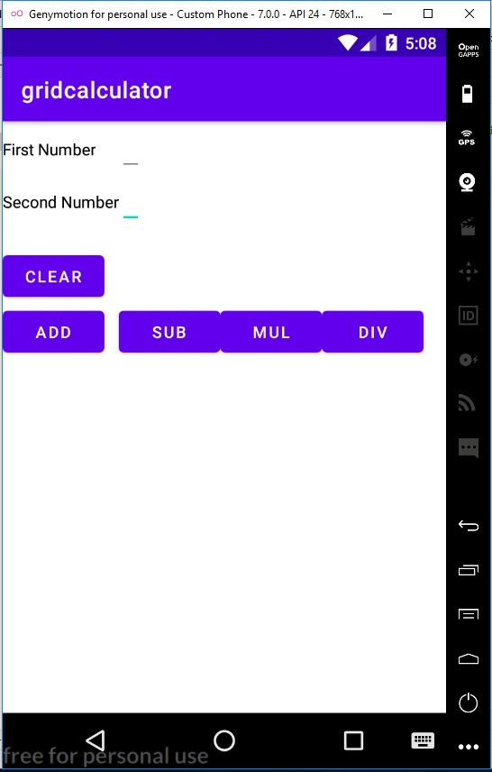

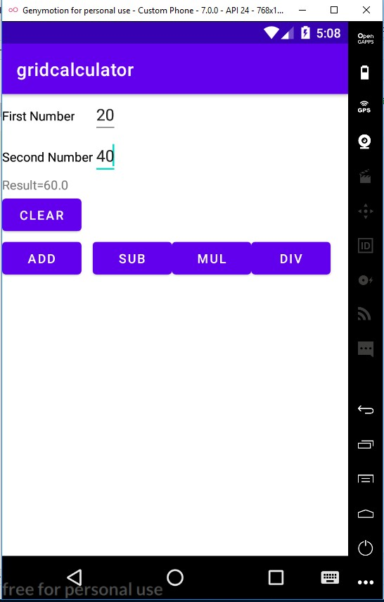

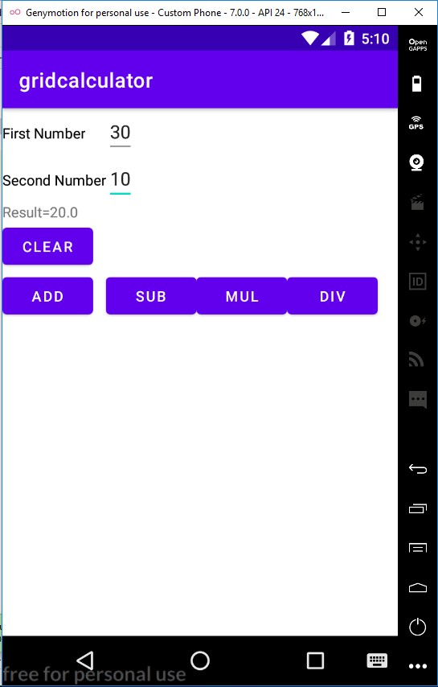 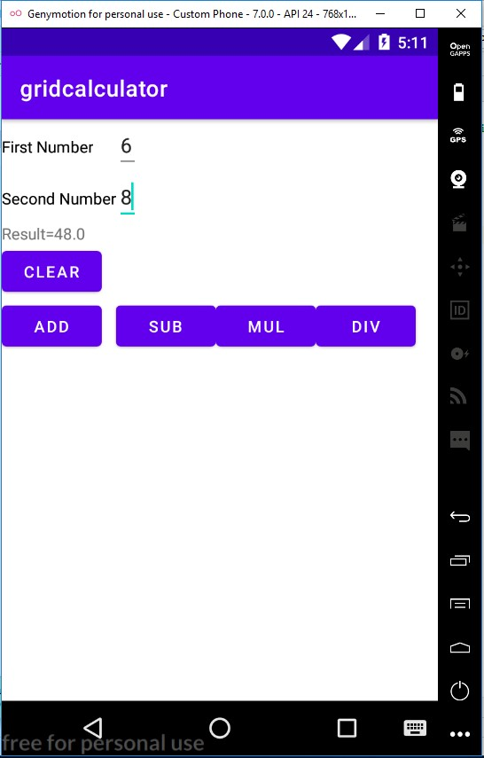

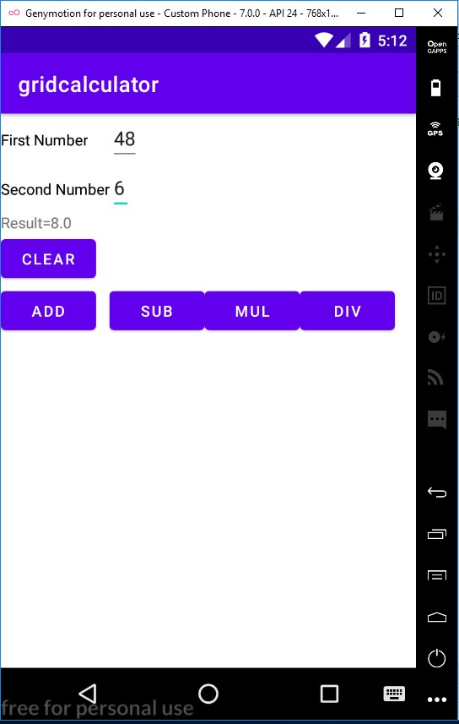

**Program No:7 Date: 09.11.23**

**Aim:**

Create a Facebook page using RelativeLayout, set properties using .xml file.

**Program Code:**

**activity_main.xml:**

<?xml version="1.0" encoding="utf-8"?>

<RelativeLayout xmlns:android="http://schemas.android.com/apk/res/android"

xmlns:app="http://schemas.android.com/apk/res-auto"

xmlns:tools="http://schemas.android.com/tools"

android:layout_width="match_parent"

android:layout_height="match_parent"

tools:context=".MainActivity">

<RelativeLayout

android:layout_width="wrap_content"

android:layout_height="wrap_content"

android:id="@+id/relativeLayout">

<ImageView

android:layout_width="match_parent"

android:layout_height="200dp"

android:id="@+id/img1"

android:src="@drawable/pic2"

android:scaleType="centerCrop"/>

<ImageView

android:layout_width="70dp"

android:layout_height="150dp"

android:id="@+id/profilePic"

android:src="@drawable/profpic"

android:layout_alignBottom="@+id/linearLayout"/>

<LinearLayout

android:layout_width="match_parent"

android:layout_height="wrap_content"

android:layout_below="@+id/img1"

android:orientation="horizontal"

android:layout_toRightOf="@id/profilePic"

android:weightSum="100"

android:id="@+id/linearLayout">

<Button

android:layout_width="70dp"

android:layout_height="40dp"

android:text="Timeline"

android:textSize="7dp"

android:layout_weight="10"/>

<Button

android:layout_width="60dp"

android:layout_height="40dp"

android:textSize="7dp"

android:text="About"

android:layout_weight="10"/>

<Button

android:layout_width="60dp"

android:layout_height="40dp"

android:textSize="7dp"

android:text="Friends"

android:layout_weight="10"/>

<Button

android:layout_width="60dp"

android:layout_height="40dp"

android:textSize="7dp"

android:text="photos"

android:layout_weight="10"/>

</LinearLayout>

<TextView

android:layout_width="wrap_content"

android:layout_height="wrap_content"

android:textStyle="bold"

android:text="Arya"

android:ems="20"

android:textColor="@color/white"

android:layout_alignBottom="@+id/img1"

android:layout_alignParentEnd="true"/>

</RelativeLayout>

<RelativeLayout

android:layout_width="match_parent"

android:layout_height="wrap_content"

android:paddingBottom="15dp"

android:layout_below="@+id/relativeLayout"

android:paddingLeft="15dp"

android:paddingRight="15dp"

android:paddingTop="15dp">

<LinearLayout

android:layout_width="match_parent"

android:layout_height="wrap_content"

android:orientation="horizontal"

android:id="@id/linearLayout">

<ImageView

android:layout_width="25dp"

android:layout_height="25dp"

android:src="@drawable/profpic"/>

<EditText

android:layout_width="match_parent"

android:layout_height="40dp"

android:id="@+id/etPost"

android:textSize="15dp"

android:layout_marginLeft="10dp"

android:hint="What's on your mind"/>

</LinearLayout>

<Button

android:layout_width="70dp"

android:layout_height="40dp"

android:text="Post"

android:textSize="10dp"

android:layout_alignParentRight="true"

android:id="@id/linearLayout"/>

</RelativeLayout>

</RelativeLayout>

**MainActivity.java**

package com.example.facebook;

import androidx.appcompat.app.AppCompatActivity;

import android.os.Bundle;

public class MainActivity extends AppCompatActivity {

@Override

protected void onCreate(Bundle savedInstanceState) {

super.onCreate(savedInstanceState);

setContentView(R.layout.activity_main);

}

}

**Result**

Program compiled successfully and output verified.

**Output**

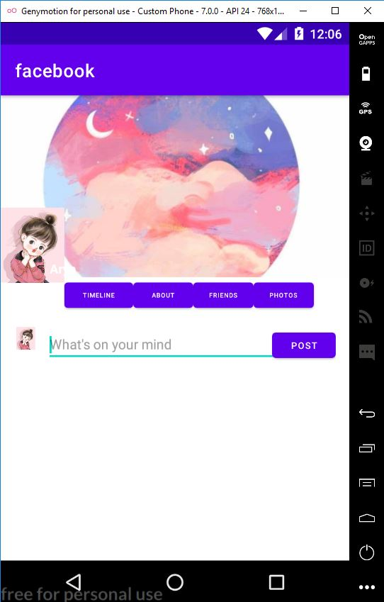

**Program No:8 Date: 16.11.23**

**Aim:**

Develop an application that toggles image using FrameLayout.

**Program Code:**

**activity_main.xml:**

<?xml version="1.0" encoding="utf-8"?>

<FrameLayout xmlns:android="http://schemas.android.com/apk/res/android"

xmlns:app="http://schemas.android.com/apk/res-auto"

xmlns:tools="http://schemas.android.com/tools"

android:layout_width="match_parent"

android:layout_height="match_parent"

tools:context=".MainActivity">

<ImageView

android:id="@+id/image1"

android:layout_width="410dp"

android:layout_height="200dp"

android:scaleType="centerCrop"

android:src="@drawable/image1"/>

<ImageView

android:id="@+id/image2"

android:layout_width="410dp"

android:layout_height="200dp"

android:scaleType="centerCrop"

android:src="@drawable/image2"/>

</FrameLayout>

**MainActivity.java**

package com.example.framelayout;

import androidx.appcompat.app.AppCompatActivity;

import android.os.Bundle;

import android.view.View;

import android.widget.ImageView;

public class MainActivity extends AppCompatActivity {

ImageView i1,i2;

@Override

protected void onCreate(Bundle savedInstanceState) {

super.onCreate(savedInstanceState);

setContentView(R.layout.activity_main);

i1 = findViewById(R.id.image1);

i2=findViewById(R.id.image2);

i2.setOnClickListener(new View.OnClickListener(){

@Override

public void onClick(View view){

i2.setVisibility(View.GONE);

i1.setVisibility(View.VISIBLE);

}

});

i1.setOnClickListener(new View.OnClickListener(){

@Override

public void onClick(View view){

i1.setVisibility(View.GONE);

i2.setVisibility(View.VISIBLE);

}

});

}

}

**Result**

Program compiled successfully and output verified.

**Output**

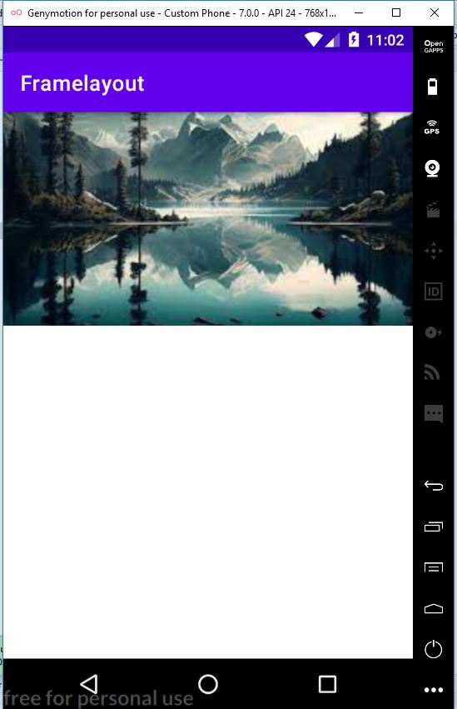 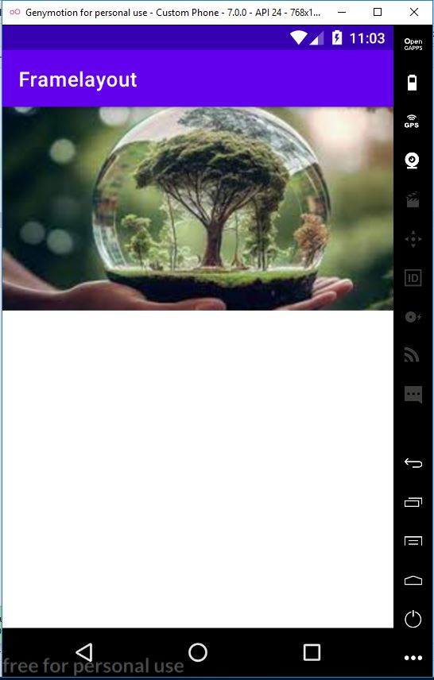

**Program No:9 Date: 16.11.23**

**Aim:**

Web application to implement implicit intent.

**Program Code:**

**activity_main.xml:**

<?xml version="1.0" encoding="utf-8"?>

<LinearLayout xmlns:android="http://schemas.android.com/apk/res/android"

xmlns:app="http://schemas.android.com/apk/res-auto"

xmlns:tools="http://schemas.android.com/tools"

android:layout_width="match_parent"

android:layout_height="match_parent"

tools:context=".MainActivity">

<EditText

android:id="@+id/t1"

android:layout_width="wrap_content"

android:layout_height="wrap_content"

android:text="http://www.google.co.in"

android:textColor="@color/design_default_color_on_secondary"/>

<Button

android:id="@+id/btn1"

android:layout_width="wrap_content"

android:layout_height="wrap_content"

android:text="click"

android:textColor="@color/design_default_color_error"/>

</LinearLayout>

**MainActivity.java**

package com.example.implictintent;

import androidx.appcompat.app.AppCompatActivity;

import android.content.Intent;

import android.net.Uri;

import android.os.Bundle;

import android.view.View;

import android.widget.Button;

import android.widget.EditText;

public class MainActivity extends AppCompatActivity {

EditText t1;

Button b1;

@Override

protected void onCreate(Bundle savedInstanceState) {

super.onCreate(savedInstanceState);

setContentView(R.layout.activity_main);

t1=findViewById(R.id.t1);

b1=findViewById(R.id.btn1);

b1.setOnClickListener(new View.OnClickListener(){

@Override

public void onClick(View view){

String url=t1.getText().toString();

Intent i=new Intent(Intent.ACTION_VIEW,Uri.parse(url));

startActivity(i);

}

});

}

}

**Result**

Program compiled successfully and output verified.

**Output**

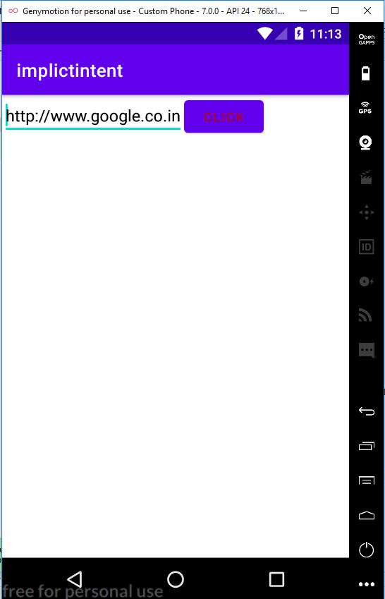 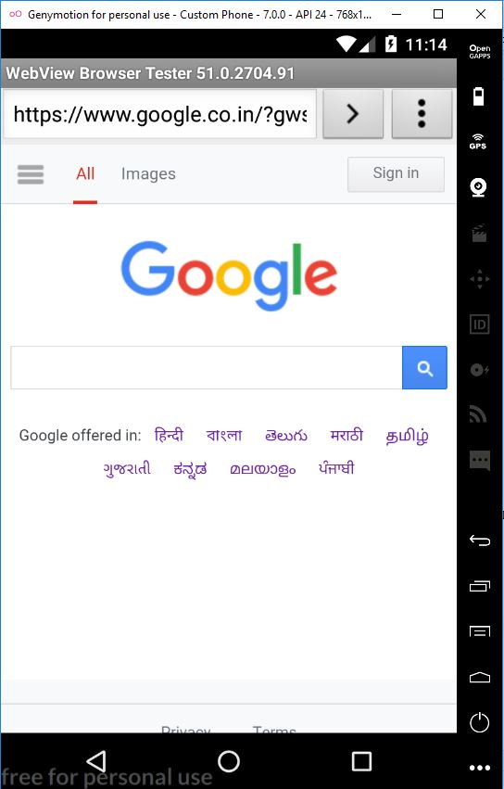

**Program No:10 Date: 16.11.23**

**Aim:**

Implement option menu to navigate two activities

**Program Code:**

**activity_main.xml:**

<?xml version="1.0" encoding="utf-8"?>

<androidx.constraintlayout.widget.ConstraintLayout

xmlns:android="http://schemas.android.com/apk/res/android"

xmlns:app="http://schemas.android.com/apk/res-auto"

xmlns:tools="http://schemas.android.com/tools"

android:layout_width="match_parent"

android:layout_height="match_parent"

tools:context=".MainActivity">

<TextView

android:layout_width="wrap_content"

android:layout_height="wrap_content"

android:text="Menu Option"

app:layout_constraintBottom_toBottomOf="parent"

app:layout_constraintLeft_toLeftOf="parent"

app:layout_constraintRight_toRightOf="parent"

app:layout_constraintTop_toTopOf="parent" />

</androidx.constraintlayout.widget.ConstraintLayout>

**menu.xml**

<?xml version="1.0" encoding="utf-8"?>

<menu

xmlns:android="http://schemas.android.com/apk/res/android">

<item android:id="@+id/item1"

android:title="File"/>

<item android:id="@+id/item2"

android:title="Edit">

<menu>

<item android:id="@+id/sub1"

android:title="Cut"/>

<item android:id="@+id/sub2"

android:title="Copy"/>

<item android:id="@+id/sub3"

android:title="Paste"/>

</menu>

</item>

<item android:id="@+id/item3"

android:title="View"/>

</menu>

**MainActivity.java**

package com.example.menunavigate;

import androidx.annotation.NonNull;

import androidx.appcompat.app.AppCompatActivity;

import android.os.Bundle;

import android.view.Menu;

import android.view.MenuItem;

import android.widget.Toast;

public class MainActivity extends AppCompatActivity {

@Override

protected void onCreate(Bundle savedInstanceState) {

super.onCreate(savedInstanceState);

setContentView(R.layout.activity_main);

}

@Override

public boolean onCreateOptionsMenu(Menu menu){

getMenuInflater().inflate(R.menu.menu,menu);

return true;

}

@Override

public boolean onOptionsItemSelected(@NonNull MenuItem item){

switch(item.getItemId()){

case R.id.item1:

Toast.makeText(this, "File Selected", Toast.LENGTH_SHORT).show();

break;

case R.id.item2:

Toast.makeText(this, "Edit Selected", Toast.LENGTH_SHORT).show();

break;

case R.id.sub1:

Toast.makeText(this, "Cut Selected", Toast.LENGTH_SHORT).show();

break;

case R.id.sub2:

Toast.makeText(this, "Copy Selected", Toast.LENGTH_SHORT).show();

break;

case R.id.sub3:

Toast.makeText(this, "Paste Selected", Toast.LENGTH_SHORT).show();

break;

case R.id.item3:

Toast.makeText(this, "View Selected", Toast.LENGTH_SHORT).show();

break;

}

return super.onOptionsItemSelected(item);

}

}

**Result**

Program compiled successfully and output verified.

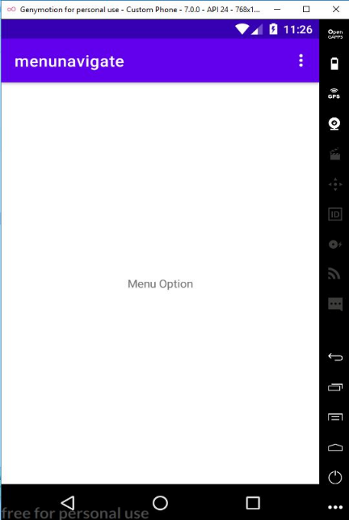 **Output**

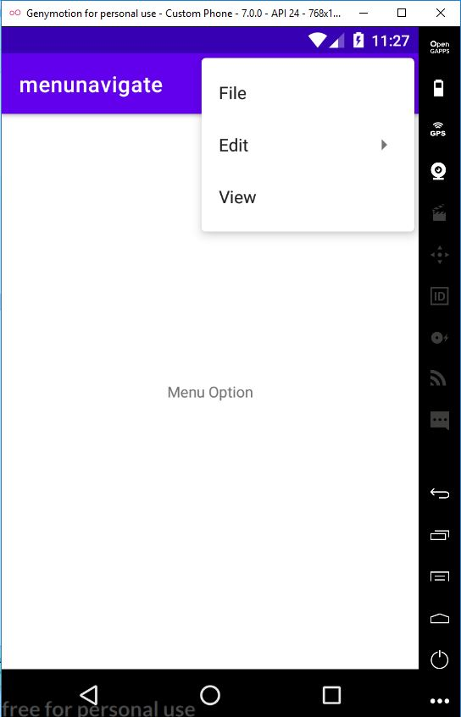 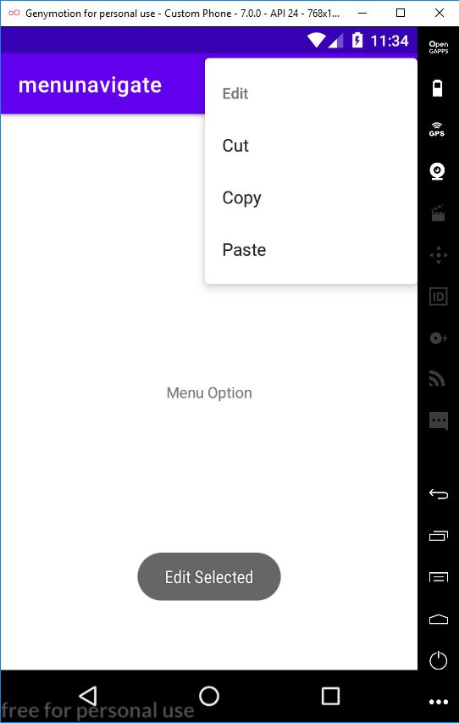

**Program No:11 Date: 17.11.23**

**Aim:**

Develop an application that uses ArrayAdapter with ListView.

**Program Code:**

**activity_main.xml:**

<?xml version="1.0" encoding="utf-8"?>

<LinearLayout xmlns:android="http://schemas.android.com/apk/res/android"

xmlns:app="http://schemas.android.com/apk/res-auto"

xmlns:tools="http://schemas.android.com/tools"

android:layout_width="match_parent"

android:layout_height="match_parent"

tools:context=".MainActivity">

<ListView

android:layout_width="wrap_content"

android:layout_height="wrap_content"

android:id="@+id/l"/>

</LinearLayout>

**MainActivity.java**

package com.example.arrayadapter;

import androidx.appcompat.app.AppCompatActivity;

import android.content.Intent;

import android.os.Bundle;

import android.view.View;

import android.widget.AdapterView;

import android.widget.ArrayAdapter;

import android.widget.ListView;

public class MainActivity extends AppCompatActivity {

ListView l;

String[] p={"APJ Abdul Kalam","Mahatma Gandhi","Jawaharlal nehru"};

@Override

protected void onCreate(Bundle savedInstanceState) {

super.onCreate(savedInstanceState);

setContentView(R.layout.activity_main);

l=findViewById(R.id.l);

ArrayAdapter <String>adapter=new ArrayAdapter<String>(this, android.R.layout.simple_list_item_1,p);

l.setAdapter(adapter);

l.setOnItemClickListener(new AdapterView.OnItemClickListener() {

@Override

public void onItemClick(AdapterView<?> adapterView, View view, int i, long l) {

if(i==0)

{

Intent s=new Intent(MainActivity.this,MainActivity2.class);

startActivity(s);

}

else if (i==1)

{

Intent s=new Intent(MainActivity.this,MainActivity3.class);

startActivity(s);

}

else if (i==2)

{

Intent s=new Intent(MainActivity.this,MainActivity4.class);

startActivity(s);

}

}

});

}

}

**activity_main2.xml**

<?xml version="1.0" encoding="utf-8"?>

<LinearLayout xmlns:android="http://schemas.android.com/apk/res/android"

xmlns:app="http://schemas.android.com/apk/res-auto"

xmlns:tools="http://schemas.android.com/tools"

android:layout_width="match_parent"

android:layout_height="match_parent"

tools:context=".MainActivity2">

<TextView

android:layout_width="wrap_content"

android:layout_height="wrap_content"

android:text="A.P.J ABDUL KALAM"

android:textSize="20dp"

android:id="@+id/txt1"

android:textAlignment="center"/>

<ImageView

android:id="@+id/imag1"

android:layout_width="200dp"

android:layout_height="200dp"

android:scaleType="centerCrop"

android:src="@drawable/imag1"

android:layout_gravity="center_vertical"/>

</LinearLayout>

**MainActivity2.java**

package com.example.arrayadapter;

import androidx.appcompat.app.AppCompatActivity;

import android.os.Bundle;

import android.widget.ImageView;

import android.widget.TextView;

public class MainActivity2 extends AppCompatActivity {

ImageView i1;

TextView txt1;

@Override

protected void onCreate(Bundle savedInstanceState) {

super.onCreate(savedInstanceState);

setContentView(R.layout.activity_main2);

i1=findViewById(R.id.imag1);

txt1=findViewById(R.id.txt1);

}

}

**activity_main3.xml**

<?xml version="1.0" encoding="utf-8"?>

<LinearLayout xmlns:android="http://schemas.android.com/apk/res/android"

xmlns:app="http://schemas.android.com/apk/res-auto"

xmlns:tools="http://schemas.android.com/tools"

android:layout_width="match_parent"

android:layout_height="match_parent"

tools:context=".MainActivity3">

<TextView

android:layout_width="wrap_content"

android:layout_height="wrap_content"

android:text="MAHATMA GANDHI"

android:textSize="20dp"

android:textAlignment="center"

android:id="@+id/txt2"/>

<ImageView

android:id="@+id/imag2"

android:layout_width="200dp"

android:layout_height="200dp"

android:layout_gravity="center_vertical"

android:scaleType="centerCrop"

android:src="@drawable/imag2" />

</LinearLayout>

**MainActivity3.java**

package com.example.arrayadapter;

import androidx.appcompat.app.AppCompatActivity;

import android.widget.ImageView;

import android.widget.TextView;

import android.os.Bundle;

public class MainActivity3 extends AppCompatActivity {

ImageView i2;

TextView txt2;

@Override

protected void onCreate(Bundle savedInstanceState) {

super.onCreate(savedInstanceState);

setContentView(R.layout.activity_main3);

i2=findViewById(R.id.imag2);

txt2=findViewById(R.id.txt2);

}

}

**activity_main4.xml**

<?xml version="1.0" encoding="utf-8"?>

<LinearLayout xmlns:android="http://schemas.android.com/apk/res/android"

xmlns:app="http://schemas.android.com/apk/res-auto"

xmlns:tools="http://schemas.android.com/tools"

android:layout_width="match_parent"

android:layout_height="match_parent"

tools:context=".MainActivity4">

<TextView

android:layout_width="wrap_content"

android:layout_height="wrap_content"

android:text="JAWAHARLAL NEHRU"

android:textSize="20dp"

android:textAlignment="center"

android:id="@+id/txt3"/>

<ImageView

android:id="@+id/imag3"

android:layout_width="200dp"

android:layout_height="200dp"

android:scaleType="centerCrop"

android:src="@drawable/imag3"

android:layout_gravity="center_vertical"/>

</LinearLayout>

**MainActivity4.java**

package com.example.arrayadapter;

import androidx.appcompat.app.AppCompatActivity;

import android.widget.ImageView;

import android.widget.TextView;

import android.os.Bundle;

public class MainActivity4 extends AppCompatActivity {

ImageView i3;

TextView txt3;

@Override

protected void onCreate(Bundle savedInstanceState) {

super.onCreate(savedInstanceState);

setContentView(R.layout.activity_main4);

i3=findViewById(R.id.imag3);

txt3=findViewById(R.id.txt3);

}

}

**Result**

Program compiled successfully and output verified.

**Output**

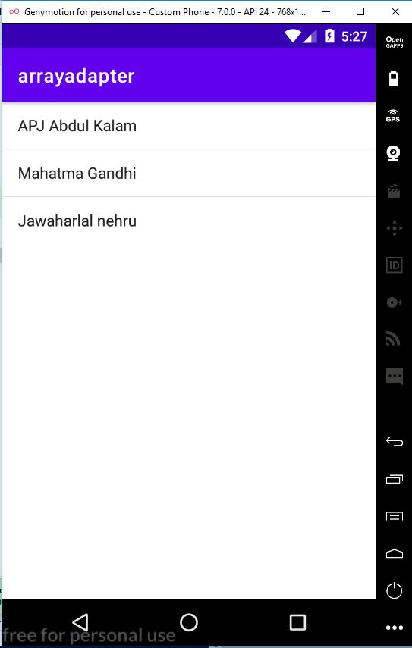 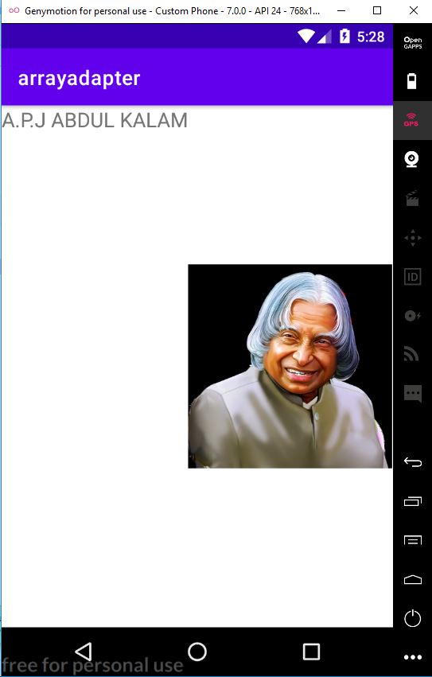

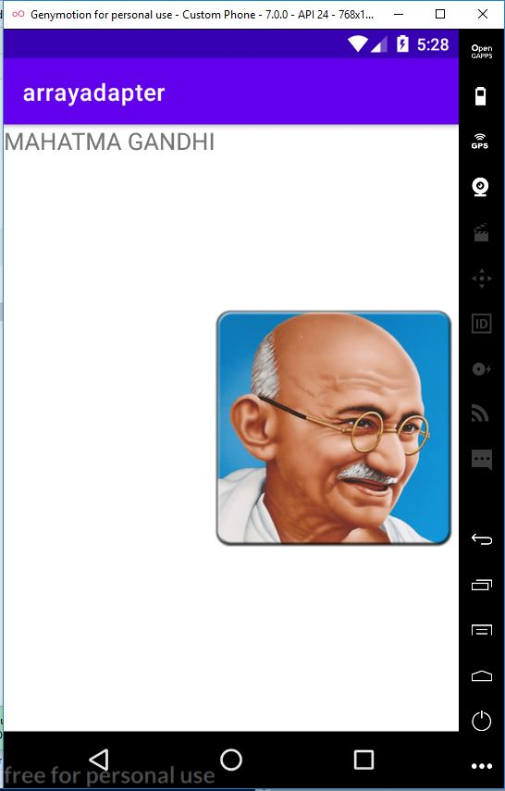 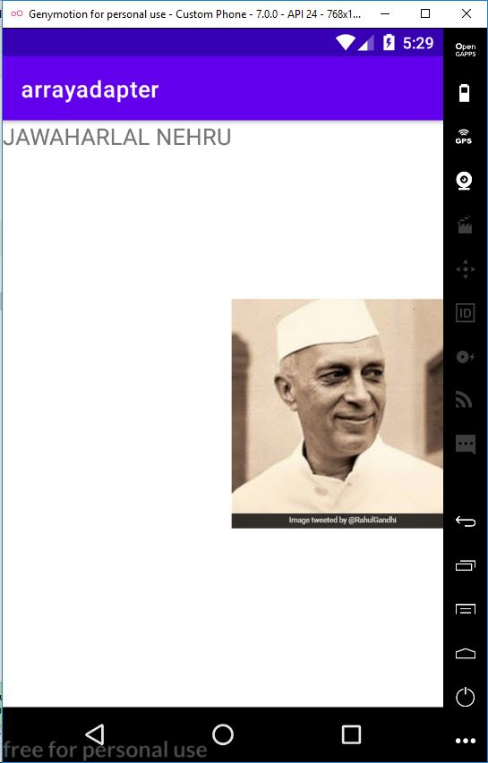

**Program No:12 Date: 22.11.23**

**Aim:**

Implement and perform exception handling.

**Program Code:**

**activity_main.xml:**

<?xml version="1.0" encoding="utf-8"?>

<LinearLayout xmlns:android="http://schemas.android.com/apk/res/android"

xmlns:app="http://schemas.android.com/apk/res-auto"

xmlns:tools="http://schemas.android.com/tools"

android:layout_width="match_parent"

android:layout_height="match_parent"

android:orientation="vertical"

tools:context=".MainActivity">

<TextView

android:layout_width="wrap_content"

android:layout_height="wrap_content"

android:text="Enter first number" />

<EditText

android:layout_width="wrap_content"

android:layout_height="wrap_content"

android:id="@+id/et1" />

<TextView

android:layout_width="wrap_content"

android:layout_height="wrap_content"

android:text="Enter the second number" />

<EditText

android:layout_width="wrap_content"

android:layout_height="wrap_content"

android:id="@+id/et2" />

<Button

android:layout_width="wrap_content"

android:layout_height="wrap_content"

android:id="@+id/b1"

android:text="SUBMIT"/>

</LinearLayout>

**MainActivity.java**

package com.example.exceptionhandling;

import androidx.appcompat.app.AppCompatActivity;

import android.os.Bundle;

import android.view.View;

import android.widget.Button;

import android.widget.EditText;

import android.widget.Toast;

class MyException extends Exception

{

MyException(String m)

{

super(m);

}

}

public class MainActivity extends AppCompatActivity {

@Override

protected void onCreate(Bundle savedInstanceState) {

super.onCreate(savedInstanceState);

setContentView(R.layout.activity_main);

EditText et1=findViewById(R.id.et1);

EditText et2=findViewById(R.id.et2);

Button b1=findViewById(R.id.b1);

b1.setOnClickListener(new View.OnClickListener() {

@Override

public void onClick(View view) {

try {

int a=Integer.parseInt(et1.getText().toString());

int b=Integer.parseInt(et2.getText().toString());

float c=(float)a/(float)b;

if(c<1)

{

throw new MyException("Number is too small");

}

}

catch(MyException e)

{

Toast.makeText(getApplicationContext(),e.getMessage(),Toast.LENGTH_LONG).show();

}

}

});

}

}

**Result**

Program compiled successfully and output verified.

**Output**

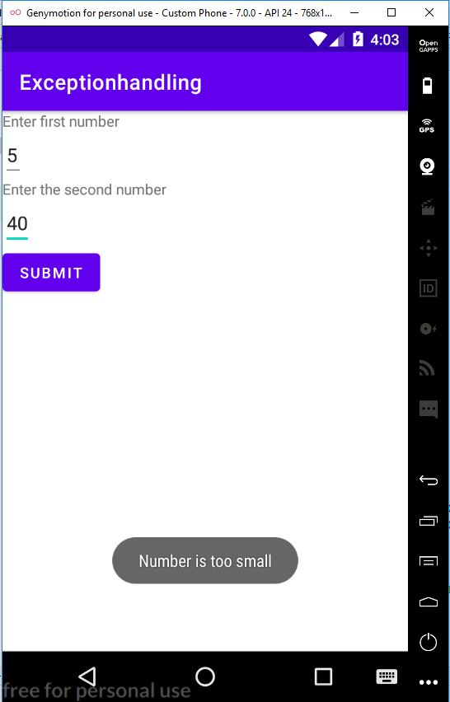

**Program No:13 Date: 22.11.23**

**Aim:**

Develop an application that implements Spinner component and perform event handling.

**Program Code:**

**activity_main.xml:**

<?xml version="1.0" encoding="utf-8"?>

<RelativeLayout xmlns:android="http://schemas.android.com/apk/res/android"

xmlns:app="http://schemas.android.com/apk/res-auto"

xmlns:tools="http://schemas.android.com/tools"

android:layout_width="match_parent"

android:layout_height="match_parent"

tools:context=".MainActivity">

<TextView

android:layout_width="wrap_content"

android:layout_height="wrap_content"

android:text="Select your nation"

android:id="@+id/t1"

android:textSize="20dp"/>

<Spinner

android:layout_width="match_parent"

android:layout_height="wrap_content"

android:layout_below="@+id/t1"

android:id="@+id/spinner"/>

</RelativeLayout>

**MainActivity.java**

package com.example.eventhandling;

import androidx.annotation.NonNull;

import androidx.appcompat.app.AppCompatActivity;

import android.os.Bundle;

import android.view.View;

import android.widget.AdapterView;

import android.widget.ArrayAdapter;

import android.widget.Spinner;

import android.widget.Toast;

public class MainActivity extends AppCompatActivity implements AdapterView.OnItemSelectedListener {

String [] country={"India","China","U.S.A","Russia","Other"};

@Override

protected void onCreate(Bundle savedInstanceState) {

super.onCreate(savedInstanceState);

setContentView(R.layout.activity_main);

Spinner spin=(Spinner)findViewById(R.id.spinner);

spin.setOnItemSelectedListener(this);

ArrayAdapter ar=new ArrayAdapter(this, android.R.layout.simple_spinner_item,country);

ar.setDropDownViewResource(android.R.layout.simple_spinner_dropdown_item);

spin.setAdapter(ar);

}

@Override

public void onItemSelected(AdapterView arg0, View arg1,int position,long id){

Toast.makeText(getApplicationContext(),country[position],Toast.LENGTH_LONG).show();

}

@Override

public void onNothingSelected(AdapterView<?>adapterView){

}

}

**Result**

Program compiled successfully and output verified.

**Output**

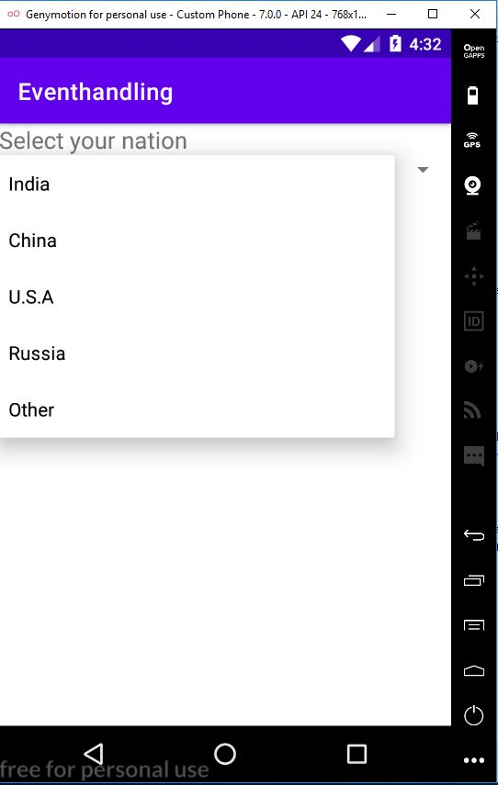 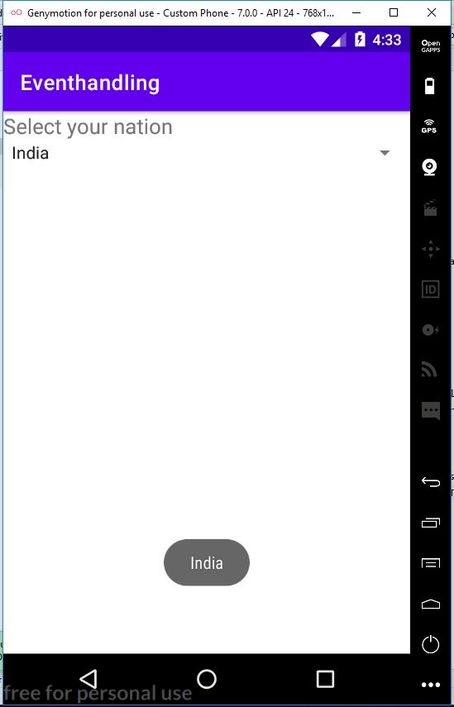

**Program No:14 Date: 24.11.23**

**Aim:**

Develop an application to draw graphic primitives.

**Program Code:**

**activity_main.xml**

<?xml version="1.0" encoding="utf-8"?>

<androidx.constraintlayout.widget.ConstraintLayout xmlns:android="http://schemas.android.com/apk/res/android"

xmlns:app="http://schemas.android.com/apk/res-auto"

xmlns:tools="http://schemas.android.com/tools"

android:layout_width="match_parent"

android:layout_height="match_parent"

tools:context=".MainActivity">

<TextView

android:layout_width="wrap_content"

android:layout_height="wrap_content"

android:text="Hello World!"

app:layout_constraintBottom_toBottomOf="parent"

app:layout_constraintLeft_toLeftOf="parent"

app:layout_constraintRight_toRightOf="parent"

app:layout_constraintTop_toTopOf="parent" />

</androidx.constraintlayout.widget.ConstraintLayout>

**MainActivity.java**

package com.example.primitives;

import androidx.appcompat.app.AppCompatActivity;

import android.content.Context;

import android.graphics.Canvas;

import android.graphics.Color;

import android.graphics.Paint;

import android.os.Bundle;

import android.view.View;

public class MainActivity extends AppCompatActivity {

@Override

protected void onCreate(Bundle savedInstanceState) {

super.onCreate(savedInstanceState);

setContentView(new myview(this));

}

private class myview extends View

{

public myview(Context context){

super(context);

}

@Override

protected void onDraw(Canvas canvas){

super.onDraw(canvas);

Paint paint=new Paint();

paint.setTextSize(40);

paint.setColor(Color.GREEN);

canvas.drawText("Circle",55,30,paint);

paint.setColor(Color.MAGENTA);

canvas.drawCircle(100,150,100,paint);

paint.setColor(Color.GREEN);

canvas.drawText("Rectanle",255,30,paint);

paint.setColor(Color.CYAN);

canvas.drawRect(250,50,400,350,paint);

paint.setColor(Color.GREEN);

canvas.drawText("Square",55,430,paint);

paint.setColor(Color.BLUE);

canvas.drawRect(50,450,150,550,paint);

paint.setColor(Color.GREEN);

canvas.drawText("Line",225,430,paint);

paint.setColor(Color.RED);

canvas.drawLine(250,500,350,500,paint);

}

}

}

**Result**

Program compiled successfully and output verified.

**Output**

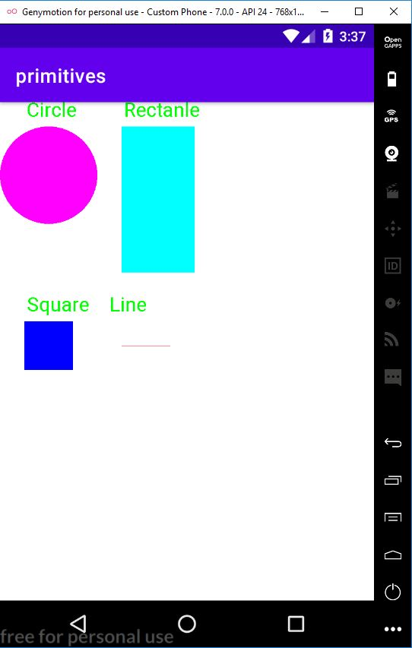

**Program No:15 Date: 24.11.23**

**Aim:**

Implement Navigation drawer.

**Program Code:**

**activity_main.xml**

<?xml version="1.0" encoding="utf-8"?>

<androidx.drawerlayout.widget.DrawerLayout

xmlns:android="http://schemas.android.com/apk/res/android"

xmlns:app="http://schemas.android.com/apk/res-auto"

xmlns:tools="http://schemas.android.com/tools"

android:layout_width="match_parent"

android:layout_height="match_parent"

android:id="@+id/drawerid"

tools:context=".MainActivity">

<LinearLayout

android:layout_width="match_parent"

android:layout_height="match_parent">

<TextView

android:layout_width="match_parent"

android:layout_height="wrap_content"

android:layout_marginTop="128dp"

android:gravity="center"

android:text="Welcome to Android"

android:textSize="18sp" />

</LinearLayout>

<com.google.android.material.navigation.NavigationView

android:layout_width="wrap_content"

android:layout_height="match_parent"

android:layout_gravity="start"

app:menu="@menu/menu" />

</androidx.drawerlayout.widget.DrawerLayout>

**menu.xml**

<?xml version="1.0" encoding="utf-8"?>

<menu xmlns:android="http://schemas.android.com/apk/res/android">

<item

android:id="@+id/account"

android:title="My Account"/>

<item

android:id="@+id/settings"

android:title="settings"/>

<item

android:id="@+id/logout"

android:title="Logout"/>

</menu>

**strings.xml**

<resources>

<string name="app_name">navigationdrawer</string>

<string name="nav_open">Open</string>

<string name="nav_close">Close</string>

</resources>

**MainActivity.java**

package com.example.navigationdrawer;

import androidx.annotation.NonNull;

import androidx.appcompat.app.ActionBarDrawerToggle;

import androidx.appcompat.app.AppCompatActivity;

import androidx.drawerlayout.widget.DrawerLayout;

import android.os.Bundle;

import android.view.MenuItem;

public class MainActivity extends AppCompatActivity {

public DrawerLayout drawerLayout;

public ActionBarDrawerToggle actionBarDrawerToggle;

@Override

protected void onCreate(Bundle savedInstanceState) {

super.onCreate(savedInstanceState);

setContentView(R.layout.activity_main);

drawerLayout = findViewById(R.id.drawerid);

actionBarDrawerToggle = new ActionBarDrawerToggle(this, drawerLayout, R.string.nav_open, R.string.nav_close);

drawerLayout.addDrawerListener(actionBarDrawerToggle);

actionBarDrawerToggle.syncState();

getSupportActionBar().setDisplayHomeAsUpEnabled(true);

}

public boolean onOptionsItemSelected(@NonNull MenuItem item) {

if (actionBarDrawerToggle.onOptionsItemSelected(item)) {

return true;

}

return super.onOptionsItemSelected(item);

}

}

**Result**

Program compiled successfully and output verified.

**Output**

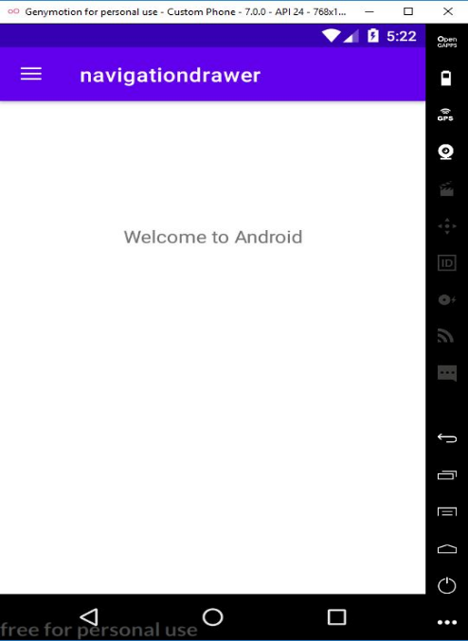 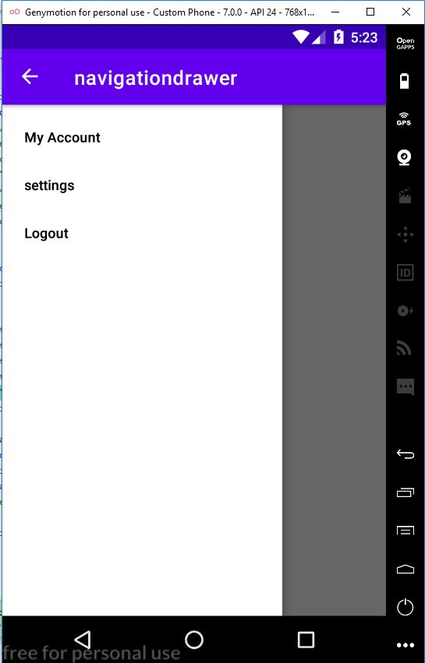

**Program No:16 Date: 05.12.23**

**Aim:**

Create database using SQLite and perform INSERT,SELSCT,UPDATE and DELETE on SQLite database.

**Program Code:**

**activity_main.xml**

<?xml version="1.0" encoding="utf-8"?>

<LinearLayout xmlns:android="http://schemas.android.com/apk/res/android"

xmlns:app="http://schemas.android.com/apk/res-auto"

xmlns:tools="http://schemas.android.com/tools"

android:layout_width="match_parent"

android:layout_height="match_parent"

tools:context=".MainActivity"

android:orientation="vertical">

<TextView

android:layout_width="wrap_content"

android:layout_height="wrap_content"

android:text="Registration"

android:textColor="@color/black"

android:textSize="25dp"

app:layout_constraintBottom_toBottomOf="parent"

app:layout_constraintLeft_toLeftOf="parent"

app:layout_constraintRight_toRightOf="parent"

app:layout_constraintTop_toTopOf="parent"

android:layout_gravity="center" />

<EditText

android:layout_width="wrap_content"

android:layout_height="wrap_content"

android:hint="Enter your Name"

android:id="@+id/name" />

<EditText

android:layout_width="wrap_content"

android:layout_height="wrap_content"

android:hint="Enter your Age"

android:id="@+id/age"/>

<EditText

android:layout_width="wrap_content"

android:layout_height="wrap_content"

android:hint="Enter your Course Name"

android:id="@+id/cn"/>

<Button

android:layout_width="wrap_content"

android:layout_height="wrap_content"

android:text="Insert"

android:id="@+id/b1"/>

<Button

android:id="@+id/b2"

android:layout_width="wrap_content"

android:layout_height="wrap_content"

android:text="Update" />

<Button

android:layout_width="wrap_content"

android:layout_height="wrap_content"

android:text="Delete"

android:id="@+id/b3"/>

<Button

android:layout_width="wrap_content"

android:layout_height="wrap_content"

android:text="View"

android:id="@+id/b4"/>

</LinearLayout>

**MainActivity.java**

package com.example.db;

import androidx.appcompat.app.AlertDialog;

import androidx.appcompat.app.AppCompatActivity;

import android.database.Cursor;

import android.os.Bundle;

import android.view.View;

import android.widget.Button;

import android.widget.EditText;

import android.widget.Toast;

public class MainActivity extends AppCompatActivity {

Dbhelper db;

@Override

protected void onCreate(Bundle savedInstanceState) {

super.onCreate(savedInstanceState);

setContentView(R.layout.activity_main);

EditText Name=findViewById(R.id.name);

EditText Age=findViewById(R.id.age);

EditText Course=findViewById(R.id.cn);

Button insert=findViewById(R.id.b1);

Button update=findViewById(R.id.b2);

Button delete=findViewById(R.id.b3);

Button view=findViewById(R.id.b4);

db=new Dbhelper(this);

insert.setOnClickListener(new View.OnClickListener() {

@Override

public void onClick(View view) {

String name=Name.getText().toString();

String age=Age.getText().toString();

String course=Course.getText().toString();

boolean checkInsertData=db.insertData(name,age,course);

if (checkInsertData==true)

Toast.makeText(MainActivity.this,"New Entry Inserted",Toast.LENGTH_LONG).show();

else

Toast.makeText(MainActivity.this,"No entry inserted",Toast.LENGTH_LONG).show();

}

});

update.setOnClickListener(new View.OnClickListener() {

public void onClick(android.view.View view) {

String name= Name.getText().toString();

String age=Age.getText().toString();

String course= Course.getText().toString();

boolean checkUpdateData= db.updateData(name,age,course);

if(checkUpdateData==true)

Toast.makeText(MainActivity.this,"Entry updated",Toast.LENGTH_LONG).show();

else

Toast.makeText(MainActivity.this,"Entry Not Updated",Toast.LENGTH_LONG).show();

}

});

delete.setOnClickListener(new View.OnClickListener() {

@Override

public void onClick(View view) {

String name= Name.getText().toString();

boolean checkUpdateData= db.deleteData(name);

if(checkUpdateData==true)

Toast.makeText(MainActivity.this,"Entry Deleted",Toast.LENGTH_LONG).show();

else

Toast.makeText(MainActivity.this,"No entry to delete",Toast.LENGTH_LONG).show();

}

});

view.setOnClickListener(new View.OnClickListener() {

@Override

public void onClick(View view) {

Cursor res=db.getData();

if(res.getCount()==0){

Toast.makeText(MainActivity.this,"No entry exist",Toast.LENGTH_LONG).show();

return;

}

StringBuffer buffer=new StringBuffer();

while(res.moveToNext()){

buffer.append("Name:"+res.getString(0)+"\n");

buffer.append("Age:"+res.getString(1)+"\n");

buffer.append("Course:"+res.getString(2)+"\n\n\n\n\n");

}

AlertDialog.Builder builder=new AlertDialog.Builder(MainActivity.this);

builder.setCancelable(true);

builder.setTitle("User Entries");

builder.setMessage(buffer.toString());

builder.show();

}

});

}

**Dbhelper.java**

package com.example.db;

import android.content.ContentValues;

import android.content.Context;

import android.database.Cursor;

import android.database.sqlite.SQLiteDatabase;

import android.database.sqlite.SQLiteOpenHelper;

import androidx.annotation.Nullable;

public class Dbhelper extends SQLiteOpenHelper {

public Dbhelper(@Nullable Context context){

super(context,"userdata.db",null,1);

}

public void onCreate(SQLiteDatabase DB){

DB.execSQL("create Table userdetails(name TEXT primary key,age text,course TEXT)");

}

public void onUpgrade(SQLiteDatabase DB,int i,int i1){

DB.execSQL("drop table if exists userdetails");

}

public Boolean insertData(String name,String age,String course){

SQLiteDatabase DB=this.getWritableDatabase();

ContentValues contentValues=new ContentValues();

contentValues.put("name",name);

contentValues.put("age",age);

contentValues.put("course",course);

long result=DB.insert("Userdetails",null,contentValues);

if(result==-1)

return false;

else

return true;

}

public Boolean updateData(String name,String age,String course)

{

SQLiteDatabase DB=this.getWritableDatabase();

ContentValues contentValues=new ContentValues();

contentValues.put("name",name);

contentValues.put("age",age);

contentValues.put("course",course);

Cursor cursor=DB.rawQuery("select * from userdetails where name=?",new

String[]{name});

if (cursor.getCount()>0) {

long result = DB.update("userdetails", contentValues, "name=?", new String[]{name});

if (result == -1)

return false;

else

return true;

}

else

{

return false;

}

}

public Boolean deleteData(String name){

SQLiteDatabase DB=this.getWritableDatabase();

Cursor cursor=DB.rawQuery("select * from userdetails where name=?",new String[]{name});

if (cursor.getCount()>0) {

long result = DB.delete("userdetails", "name=?", new String[]{name});

if (result == -1)

return false;

else

return true;

}

else

return false;

}

public Cursor getData(){

SQLiteDatabase DB=this.getWritableDatabase();

Cursor cursor=DB.rawQuery("select * from userdetails",null);

return cursor;

}

}

**Result**

Program compiled successfully and output verified.

**Output**

